Ministry of Education of the Republic of Moldova

Technical University of Moldova

Department of Software Engineering and Automatic

REPORT

CDE
Laboratory work no. 6

Transistor-based amplifiers

Performed by:
st. gr. FAF-161 Terman Emil

Verified by:
Prof. dr. hab. O. Lupan
(14.12.2017)

Chişinău - 2017
Purpose of the work: we will study the operation of the broadband voltage amplifier stages in the RC coupling, equipped with bipolar transistors with non-reactive EC and negative current reactants. It increases the aplitudine and frequency characteristics for all assemblies and cases studied.

General theory:
It is called an electronic amplifier an electronic circuit that converts the low power signal applied to the input into an output signal with much higher power or voltage coming from the same form of time variation as the excitation signal.
The amplifier floor is equipped with an amplifier element, input and output circuits, passive elements and electrical power supply. The transistors in the electric circuits are considered active because they can control the power obtained from the power sources according to the excitation signal ) providing more power than the one being charged by the signal source. The passive elements are inductors, capacitors, resistors.

Amplification factors. One of the basic parameters of the amplifier is the amplification factor-the ratio between the variable component of the load signal and the variable component of the input signal.

K_{U} =; * Voltage amplification
K_{I} =; *Current amplification
K_{P} =; *Power amplification

Distorsions. In the real amplifiers the output signal form is different from the input signal, this change of form being called distortion. There are two main types of distortion: linear and nonlinear. Linear disistors are determined by the variation of the modulus of the amplification coefficient with the frequency and Frequency phase variation. Nonlinear disistors are determined by the nonlinearity of the static characteristics of the transistors. The nonlinearity is usually of great importance in high amplitude signals.
K_{D} =/P₁=/U₁² == /I₁², where n is - order number of the respective superior harmonics;
P_{1,}U_{1,} I₁- power, voltage and current corresponding to the fundamental harmonics.

Transfer amplitude characteristics. The transfer characteristic is the correspondence between the output voltage and the input at a constant frequency.

D[db] = 20lg(U_{int mac}/U_{int min})

Frequency characteristics of the amplifier represents the frequency variation of the amplifier factor module. The ideal characteristic was a right parallel to the axis of the abscissae and the distance equal to the modulus of the amplification factor. Reducing the amplification factor at low frequencies is caused by the reactive elements present in the scheme and the reduction at high frequencies - by the parasitic capacitances of the transistor and the load, as well as by the amplification factor of the frequency transistor. The output of the output signal is manifested by the distortion factor.
M_{j} = = 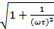; where Mj, Ms - distortion factors at low and high frequencies;
M_{s} = = ; - the circular frequency at which the linear distortion factor is estimated;
- time constant of the amplifier at low and high frequencies;

Phase characteristics is the dependence of the phase shift phase between the output voltage and the input voltage at the frequency variation. The positive values correspond to the exceedances and the negative values of the angle of the output signal to the input signal.

Amplification reactions. The reactants are the process of transferring the signal from the output circuit of the amplifier, called reaction signal, into the input circuit. If the output signal phase coincides with the input phase then the reaction is called positive, otherwise the reaction is called negative.

K_{u.r.p}= ; K_{u.r.p} ,K_{u.r.n} – amplification factors of the amplifier with positive and negative reactants;
K_{u.r.n}= ; K_{u} - the amplifier factor of the non-frequency amplifier;
- the transfer factor of the reactant circuit;

Working process:
1. Meet the work platform, the measuring devices and the food sources of the stand.
2. Assemble the bipolar transistor amplifier stage circuit in connection with the common emitter (EC) according to scheme 5.4.
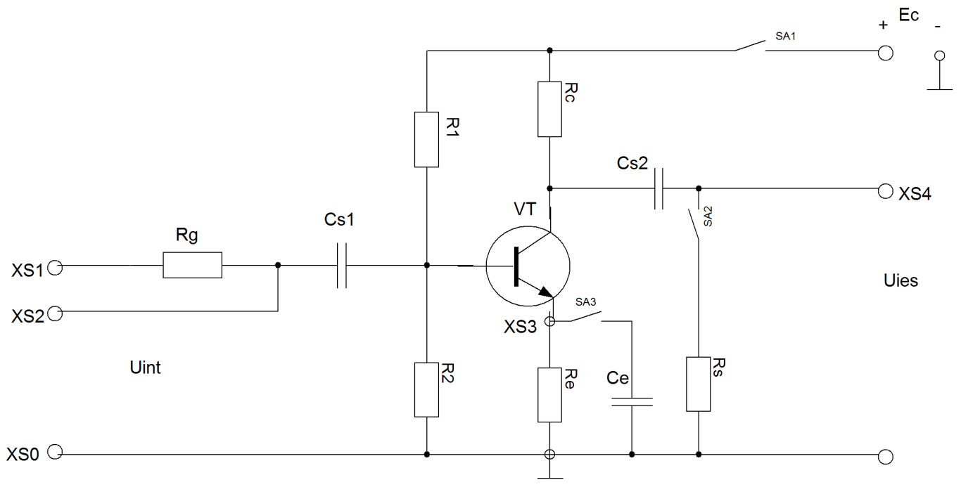
Fig. 1: Electric Emitter Emitter (EC)

3. Input resistance of amplifier stage without reactance is determined (SA2 switch disconnected
and with negative reactants in series current (SA2 switch connected). The experiments are performed at the standard frequency of the signal f = 1000Hz.
The XS1 and XS0 jacks connect the G signal generator, and the XS2 and XS0 jacks the PV voltmeter. Gradually the signal increases until the voltmeter shows Uint = 10mv. Remove the voltmeter and connect to the XS1 and XS0 jacks and set the voltage of the Eg generator. It causes the Eg-Uint voltage drop on the Rg resistance and the input current:
I_{int} =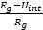

Calculate the input resistance of the amplifier stage.
R_{int} = = 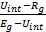
R_{int} resistance is calculated for two values of the input voltage:=10mV and =50mV

4. Determine the output resistance of the amplifier. At the output of the amplifier, connect a box with decadic resistors and a PV voltmeter according to the diagram in fig. 5.4. The XS switch is set to position 1 and the output voltage for the empty operation (Rs =) Uies .g. It gradually introduces the resistances decades until the output voltage drops to Uies =. The resistance attained by this result equals the output resistance of the Ries amplifier. In the absence of the decade box on the common emitter scheme it will be considered as R_{ies}=R_{c}.

5. Input voltage amplifier input voltage at the constant frequency (f = 1000Hz) is measured. The experimental data are output for two cases: no reaction and negative reaction and they are recorded in Tables 5.1 and 5.2.
U_{int},mv | 0 | 1 | 5 | 10 | 20 | 30 | 40 | 50 | 75 | 100
U_{ies},mv | 8 | 90 | 320 | 670 | 1100 | 1800 | 2340 | 2800 | 4000 | 5000

* Experiment data to lift EC signal transfer capability without reaction

Tab. 1

* Experiment data to lift the EC Amplifier Negative Reagent Transfer Feature.

Uint,mv | 0 | 10 | 50 | 100 | 250 | 500 | 800 | 1000 | 1500 | 1800
U_{ies},mv | 1 | 51 | 240 | 450 | 1182 | 2300 | 3680 | 4700 | 5230 | 5350
Tab. 2

6. Measurement of amplification factor is dependent on the frequency of input signal of amplifier stage without feedback and with negative reactants. At the input of the amplifier the Uint = 10mV signal is constantly kept. The experimental data are written in Table 5.3:
* Experimental data for elevation of frequency characteristics
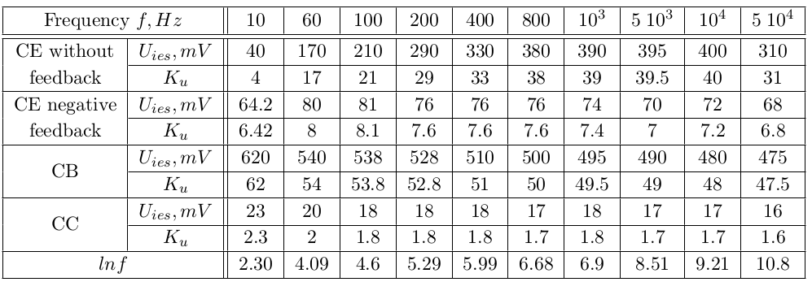
Tab. 3

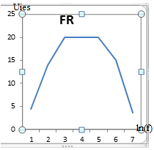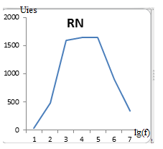
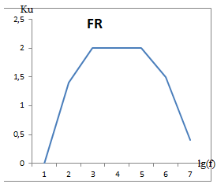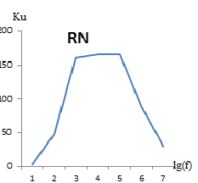
Fig. 2
K_{U} == 20mV/10mV=2
In the absence of the decadication box the common emitter scheme will be considered R_{ies}=R_{c}.
K_{i} = K_{u};
R_{int} = =
R_{int} resistance is calculated for two values of the input voltage:=10mV si =50mV

K_{U} =; * Voltage amplification
K_{I} =; *Current amplification
K_{P} =; *Power amplification
7. Points 1 ... 6 repeat for amplifier floors in BC and CC connection.
8. Using the data in the table we plot the amplitude and frequency characteristics for each separate amplifier stage. It is the frequency on the abscissa axis at logarithmic scale lnf (or lgf).
9. From the frequency characteristics we determine the voltage amplification factor at average frequency (where k_{u} = const). Calculate the amplification factors in current and power:
K_{i} = K_{u}; K_{p}= K_{U}*K_{i} ;
10. Determine linear distortion factors at low and high frequencies Mj and Ms.
The common collector amplifier (CC)
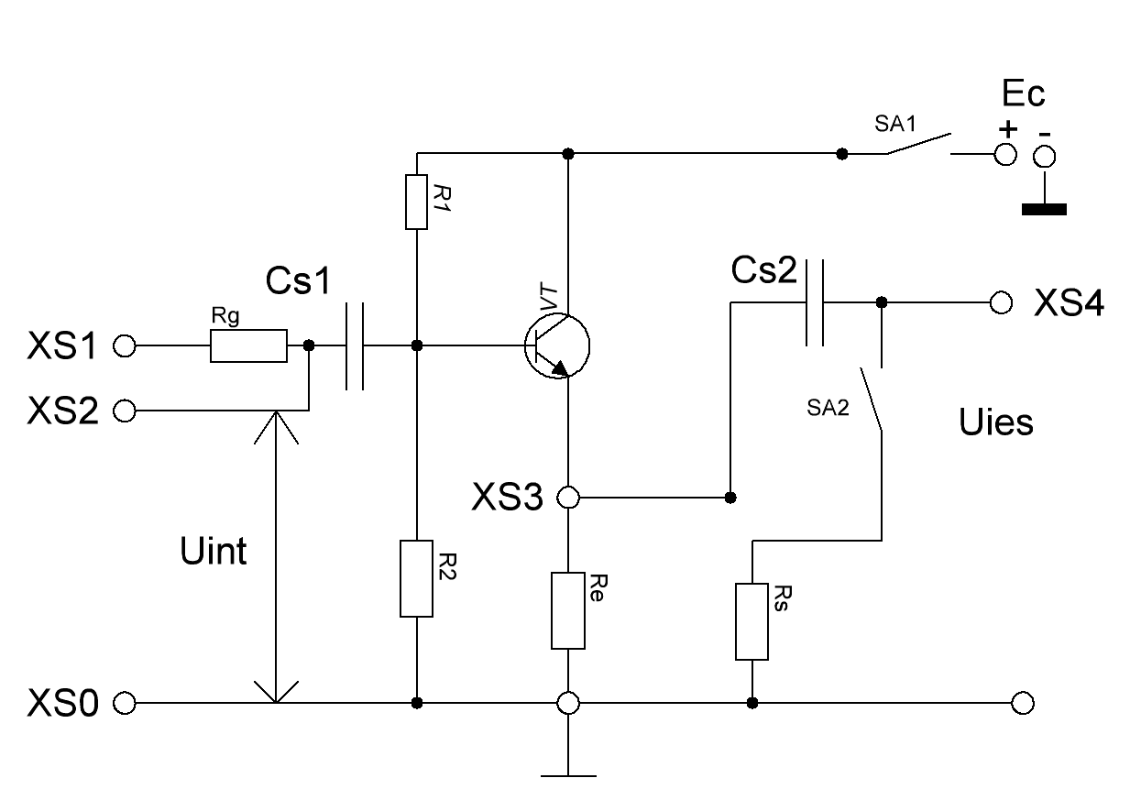
Fig. 3
U_{int},mv | 0 | 1 | 5 | 10 | 20 | 30 | 40 | 50 | 75 | 100
U_{ies},BC | 0 | 6 | 41 | 64 | 130 | 190 | 260 | 320 | 490 | 660
U_{ies},CC | 0 | 0.7 | 2.7 | 5.8 | 10.4 | 16 | 20 | 27 | 39 | 55

Tab. 4

Frequency  f,Hz |  | 10 | 60 | 100 | 200 | 400 | 800 | 10³ | 5*10³ | 10⁴ | 5*10⁴ | 10⁵ | 2*10⁵ | 5*10⁵ | 10⁶ | 2*10⁶ | 5*10⁶
BC farareacti | U_{ies},  mv | 55 | 63 | 62 | 62 | 62 | 62 | 61 | 57 | 50 | 5 | 2 | 4 | 5 | 6 | 1 | 1
BC farareacti | K_{u}
CC | U_{ies},  mv | 4 | 5 | 5 | 5.2 | 5.6 | 5.8 | 5.7 | 5.2 | 4.4 | 0.7 | 0.7 | 0.7 | 0.7 | 0.7 | 0.7 | 0.7
CC | K_{u}
Tab. 5

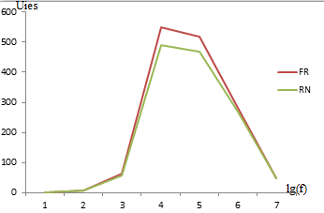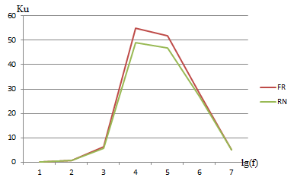
Fig. 4

Ku=Uies/Uint
K_{i} = K_{u}
R_{int} = =
R_{int} resistance is calculated for two values of the input voltage: =10mV si =50mV

K_{U} =; * Voltage amplification
K_{I} =; *Current amplification
K_{P} =; *Power amplification

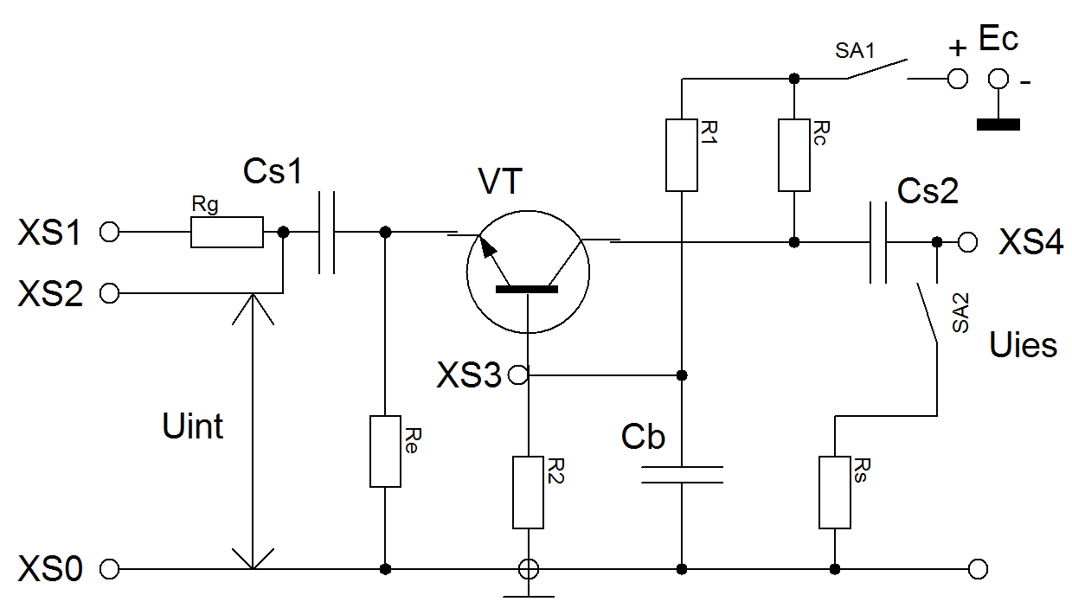
Fig. 5: Electrical scheme of the common base amplifier:

Ku=Uies/Uint
In the absence of the decadication box the common emitter scheme will be considered as R_{ies}=R_{c}.
K_{i} = K_{u};
R_{int} = =
R_{int} resistance is calculated for two values of the input voltage: =10mV si =50mV
K_{U} =; * Voltage amplification
K_{I} =; *Current amplification
K_{P} =; *Power amplification
Conclusion:
By conducting the laboratory work we studied the amplification stages in the EC, BC and CC connections.
1) In this laboratory work, we observed the transistors’ gain factor in practice.
2) Also, we saw in practice what positive and negative feedback in amplification is.
3) We plotted the frequency characteristics of all configurations.
4) Finnaly, we noticed how the output voltage in all configurations was bigger than the input voltage.

